Level barriers Metaheuristic Outcome Strategy Network for Massive Fabrication

**Preface**

**TABLE OF CONTENTS**

**1. SOFTWARE DEVELOPMENT LIFE CYCLE**

**2. PLATFORM KNOWLEDGE**

**3. ABOUT PROJECT**

3.1 ABSTRACT

3.2 SCOPE OF THE PROJECT

3.3 EXISTING SYSTEM

3.3.1 DISADVANTAGES

3.4 PROPOSED SYSTEM

3.4.1 ADVANTAGES

**4. BOTTOM LINE AND FUTURE ENHANCEMENT**

**5. SOFTWARE AND HARDWARE REQUIREMENTS**

**1. SDLC (Software Development Life Cycle)**

The Software Development Life Cycle is a systematic process for building software that ensures the quality and correctness of the software built. SDLC process aims to produce high-quality software which meets customer expectations. The software development should be completed within the pre-defined time frame and cost.

**SDLC Phases**

The entire SDLC process is divided into the following stages:

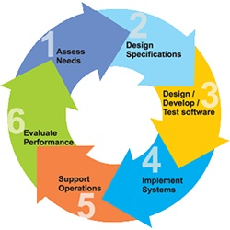

* Phase 1: Requirement collection and analysis
* Phase 2: Feasibility study
* Phase 3: Design
* Phase 4: Coding
* Phase 5: Testing
* Phase 6: Installation/Deployment
* Phase 7: Maintenance

**2. PLATFORM KNOWLEDGE**

**Introduction to java**

Java programming language was originally developed by Sun Microsystems which was initiated by James Gosling and released in 1995 as a core component of Sun Microsystems' Java platform. Initially, the language was called “Oak” but it was renamed as “Java” in 1995. The primary motivation of this language was the need for a platform-independent language. Finally, Java is for Internet Programming where C was to System Programming.

**Java architecture**

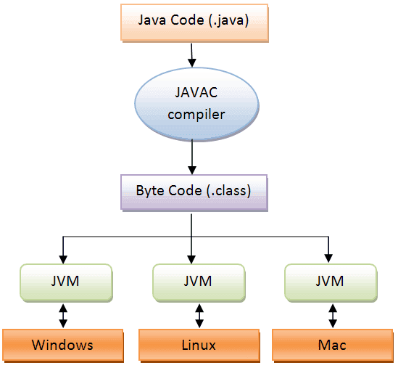Java is a high-level Object-oriented programming language. A program written in high level language cannot be run on any machine directly. First, it needs to be translated into that particular machine language. The javac compiler does this thing, it takes java program (.java file containing source code) and translates it into machine code (referred as byte code or .class file). Java Virtual Machine (JVM) is a virtual machine that resides in the real machine (your computer) and the machine language for JVM is byte code. JVM executes the byte code generated by compiler and produce output. JVM is the one that makes java platform independent.

**3. DOMAIN KNOWLEDGE:**

**ARTIFICIAL INTELLIGENCE**

**Overview**

Artificial Intelligence (AI) is the simulation of human intelligence process by machines, especially computer systems. These processes include the acquisition of information and rules for using the information, using rules to reach approximate or definite conclusions and self-correction.

Artificial Intelligence has the capability to find patterns in big data to learn and reveal hidden information or deliver solutions to deliver complex problems. It is an automated processes.

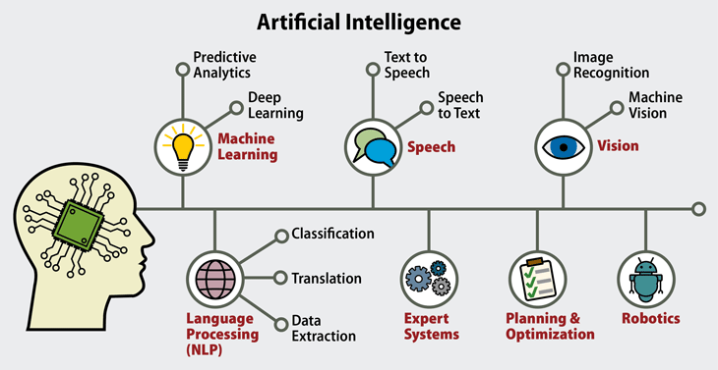

**Types of Artificial Intelligence**

Artificial Intelligence categorized into four types are:

**Reactive Machines:**

This means they cannot form memories or past experiences to influence present made decisions they can only react to currently existing situations.

**Limited Memory:**

This is comprised of machine learning models that derive knowledge from previously-learned information, stored data, or events.

**Theory of Mind:**

It refers to the understanding that others have their own beliefs, desires and intentions that impact the decisions they make.

**Self-Awareness:**

It is also called as consciousness. Machines with self-awareness understand their current state and can use the information to infer what others are feeling.

**COMPONENTS OF ARTIFICIAL INTELLIGENCE**

**Types of Models**

* Deep Learning
* Machine Learning
* Neural networks

**Deep Learning**

Deep learning is a subset of machine learning in artificial intelligence (AI) that has networks capable of learning unsupervised from data that is unstructured or unlabeled. Also known as deep neural learning or deep neural network.

**Machine Learning**

Machine learning is an application of artificial intelligence (AI) that provides systems the ability to automatically learn and improve from experience without being explicitly programmed. Machine learning focuses on the development of computer programs that can access data and use it learn for themselves.

**Neural Networks**

A neural network is a series of algorithms that endeavors to recognize underlying relationships in a set of data through a process that mimics the way the human brain operates. In this sense, neural networks refer to systems of neurons, either organic or artificial in nature.

**Theoretical Types of Artificial Intelligence:**

* Artificial Narrow Intelligence(ANI)
* Artificial general Intelligence(AGI)
* Artificial Super Intelligence(ASI)

**Artificial Narrow Intelligence (ANI)**

Artificial narrow intelligence refers to a computer's ability to perform a single task extremely well such as crawling a webpage or playing chess.

**Artificial General Intelligence(AGI)**

Artificial general intelligence (AGI) is the intelligence of a machine that can understand or learn any intellectual task than a human being.

**Artificial Super Intelligence(ASI)**

Artificial super intelligence is a hypothetical agent that possesses intelligence far surpassing that of the brightest and most gifted human minds.

**Applications of Artificial Intelligence**

* Image recognition
* Speech recognition
* Natural language generation
* Sentiment Analysis
* Chatbots.

**Level barriers Metaheuristic Outcome Strategy Network for Massive Fabrication**

**3. ABOUT THE PROJECT**

**3.1 Abstract**

In general, reverse logistics has involved all supply chain layers across a wide range of industries. We are satisfying the logic with the sophisticated multi-objective optimization algorithm in different occurrence in our proposed model of approach. Although some actors in the network have been coerced to return products, others have accomplished so deliberately attributable to the value of used goods, reverse logistics has emerged as a crucial competency in today's supply chains. Commercial enterprises routinely seek out revolutionary approaches to enhance their operations, enhance client happiness, and maintain a competitive advantage over their rivals in the extremely competitive manufacturing sector. For about a decade, reverse logistics has been considered a way to bring these things to life. The objective is to define the cornerstone of reverse logistics and demonstrate how it can be leveraged as a management strategy. This paper also provides some of the ways in which decisions regarding reverse logistics have an impact on the environment and vice versa, as there has been a growing concern about the need to control global pollution. In this paper implementing the data analytics methodology will reduce the management issues in the logistics like warehouse utilization, handling the returns, processing the returned products etc. while reverse logistics takes environmental considerations into account for all logistics activities. Consumption of nonrenewable natural resources, air emissions, traffic congestion and road use, noise pollution, and the disposal of hazardous and nonhazardous waste are the most prominent environmental issues in logistics.

**3.2 Scope of the project**

Reverse logistics is the process of moving goods from their typical final destination for the purpose of capturing value, or proper disposal. It encompasses all operations related to the upstream movement of goods and materials. Manufacturers across all sectors are catching on to this trend. Like other processes in the supply chain, is an important part of service lifecycle management and can be made more profitable and efficient with better planning, management, and execution. In both positive and negative ways, reverse logistics can have a significant impact on a business's bottom linemaking the distinction that reverse logistics is distinct from waste management, which primarily refers to the efficient and effective collection and processing of waste. The definition of waste is what really matters in this case. This is a big problem because the term has serious legal implications, like the fact that waste often can't be imported. Reverse Logistics focuses on those flows where some value can be recovered and the product enters a (new) supply chain. Green logistics, on the other hand, focuses solely on forward logistics from producer to customer.

**3.3 Existing System**

Research and Markets says that this rise in the number of returns and replacements is due to the rapid expansion of the e-Commerce industry. There needed more space to process more returns. In comparison to forward logistics, reverse logistics typically necessitates up to 20% more space. If the product is delivered and returned back then there is loss of business and in order to maintain it will lead to difficult in huge number of returns. Supply chains have become more complicated, customer expectations have changed, and today's markets are dynamic and competitive. Customers today have higher expectations regarding delivery times and service quality when placing orders with the company. In a competitive market, customers expect their logistics partners to support them in resolving problems and expanding. If they are not satisfied with their purchases, customers should be able to return them easily. It can run the risk of alienating customers and preventing them from making subsequent purchases from market do not have an efficient platform for reverse logistics.

**3.3.1 Disadvantages**

* Time and cost are wasted for damaged returns.
* Customer satisfaction and expectation will be disturbed
* More complex return flows with the products
* Maintaining warehouse space occupancy is difficult

**3.4 Proposed System**

In general Transportation, inventory management, and warehousing are all crucial steps in the supply chain that require technology to function effectively, accurately, and economically. These components of the supply chain may actually be competitive advantages. Time-consuming and frequently detrimental to profits is the process of returning customer returns to the warehouse without damaging the supply chain or introducing counterfeit goods. By lowering the likelihood that customers will ever need to return the goods, technology enables businesses to reduce the number of products entering the returns process. The packing team can match the order to the item and avoid sending the wrong color or size by tracking SKUs with smart tags as they enter the warehouse and scanning them as they leave. The data management technique can assist you in comprehending all of the costs associated with recovering a product and figuring out how to optimize transportation to avoid losing the return's value due to shipping costs (for example, making better use of space on delivery trucks bound for distribution centers to reduce empty miles). It can also assist in identifying patterns of fraud and sound the alarm if it believes a customer is falsifying a return, preventing the item from being returned before money is spent on shipping it back.

**3.4.1 Advantages**

* Reduces cost to management for the returns
* Reselling and maintaining the products in the warehouse is monitored
* Prevent loss for the manufacturing unit.
* Greater customer satisfaction
* Process standardization will be improved

**4. BOTTOM LINE AND FUTURE ENHANCEMENT**

In fact, manufacturing companies rely heavily on reverse logistics to remain competitive. Also, having a good reverse logistics process in place reduces costs, makes better use of resources, makes customers happier and more loyal, shortens the time it takes to process returns, and gives your business a greener image. These businesses should also pay more attention to the processes of reverse logistics because the cost of reverse logistics is between 5 and 10 percent of the total costs of logistics, which is a small percentage but still represents an opportunity for improvement. Additionally, if a company is going to remain in business for an extended period of time, it must strive to continuously improve its process. Manufacturers must take responsibility for the safe disposal of their waste and reuse as much waste material as possible in order to be good corporate citizens. This project supports the effective reverse logistics to improve the business organization to minimize the losses and increase productivity with the help of implementing learning methodologies and techniques in this process. Future enhancement will include concentrating on the additional issues and utilize the learning technique to refine the business.

**5. HARDWARE AND SOFTWARE REQUIREMENTS**

**Hardware requirements:**

* Processor : Intel (R) Pentium (R)
* Speed : 1.6 GHz and Above
* RAM : 4 GB and Above
* Hard Disk : 120 GB
* Monitor : 15’’ LED SVGA
* Input Devices : Keyboard, Mouse

**Software requirements:**

* Operating system : Windows 7 / 8 / 8.1 / 10
* Coding Language : JAVA / J2EE
* Java Version : JDK 8
* IDE : Eclipse Oxygen
* Database : MySQL v5.1
* Database Tool : Heidi SQL v11.0
* Application Server : Apache Tomcat 8.X / 9.X